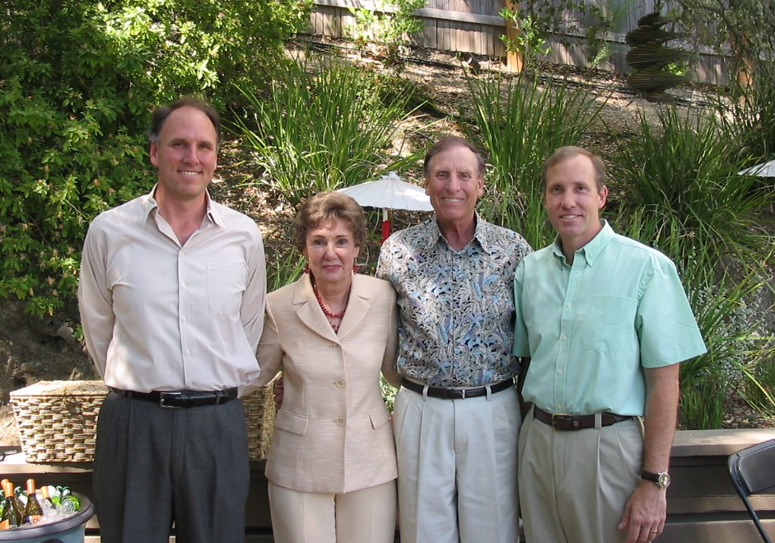

John Philip, Marg, Philip, Aaron Russell Wolfe

Marg and Philip 50th Wedding Anniversary – 2008

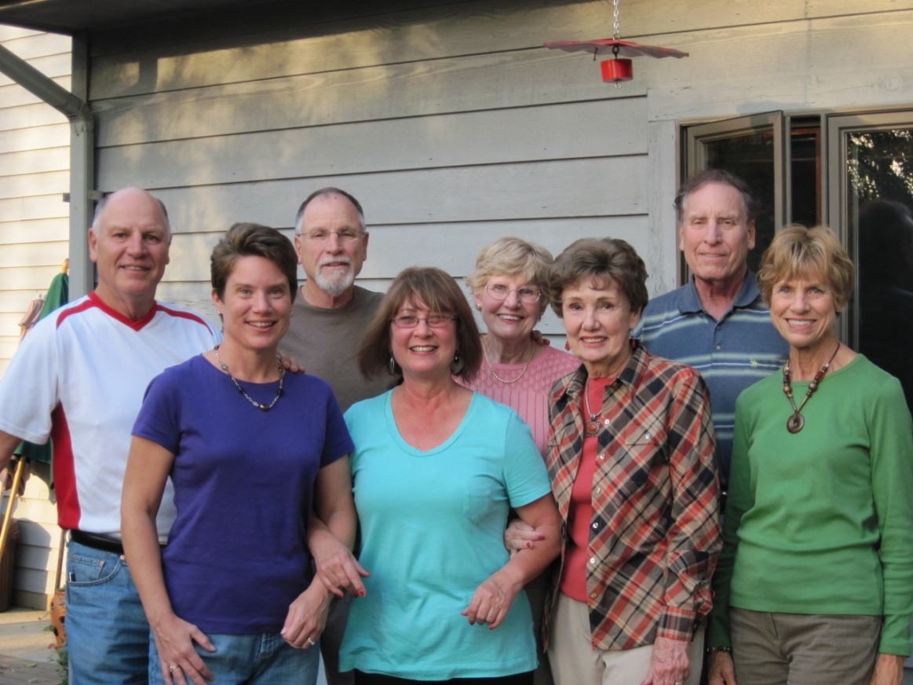

John, Elaine, Nelson, Sandy, Lois, Marg, Philip, Mary Jo – 2010